Login page

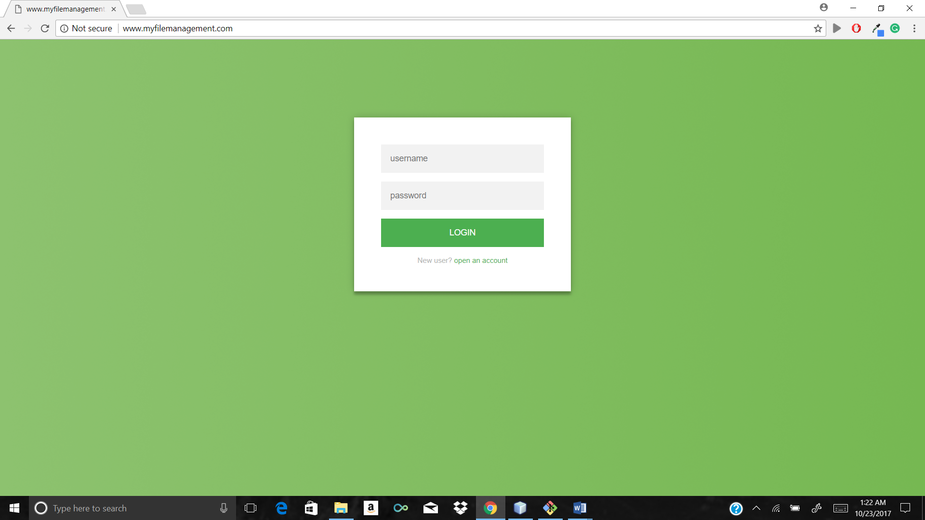

Registration page

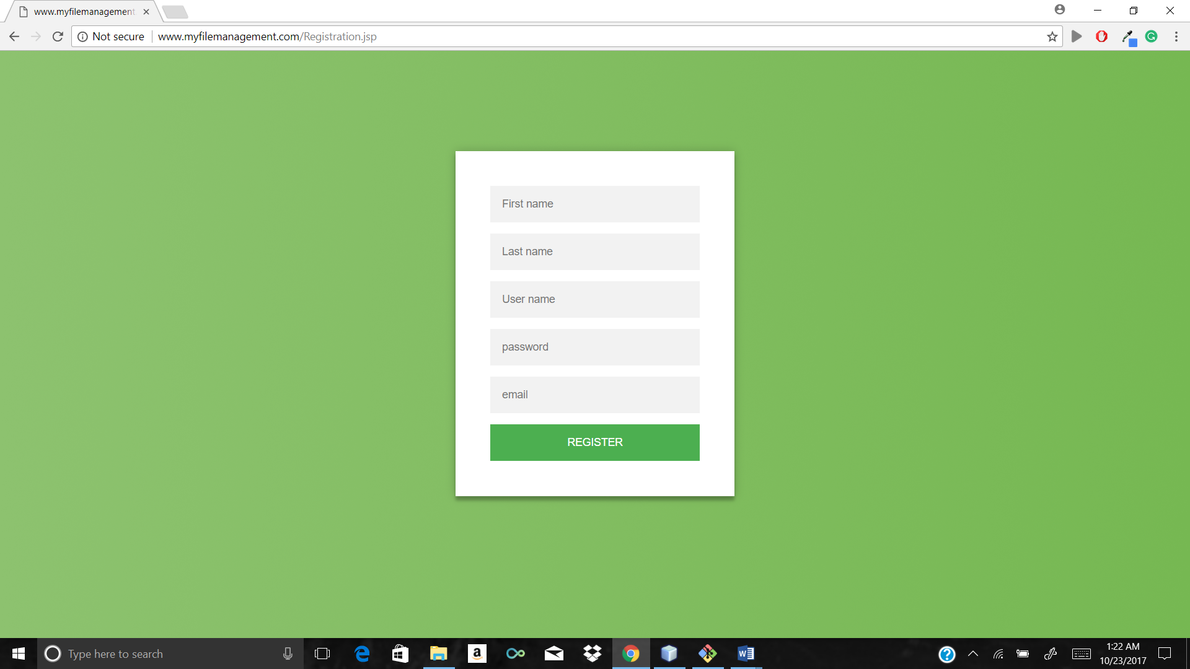

After login multiple file to upload

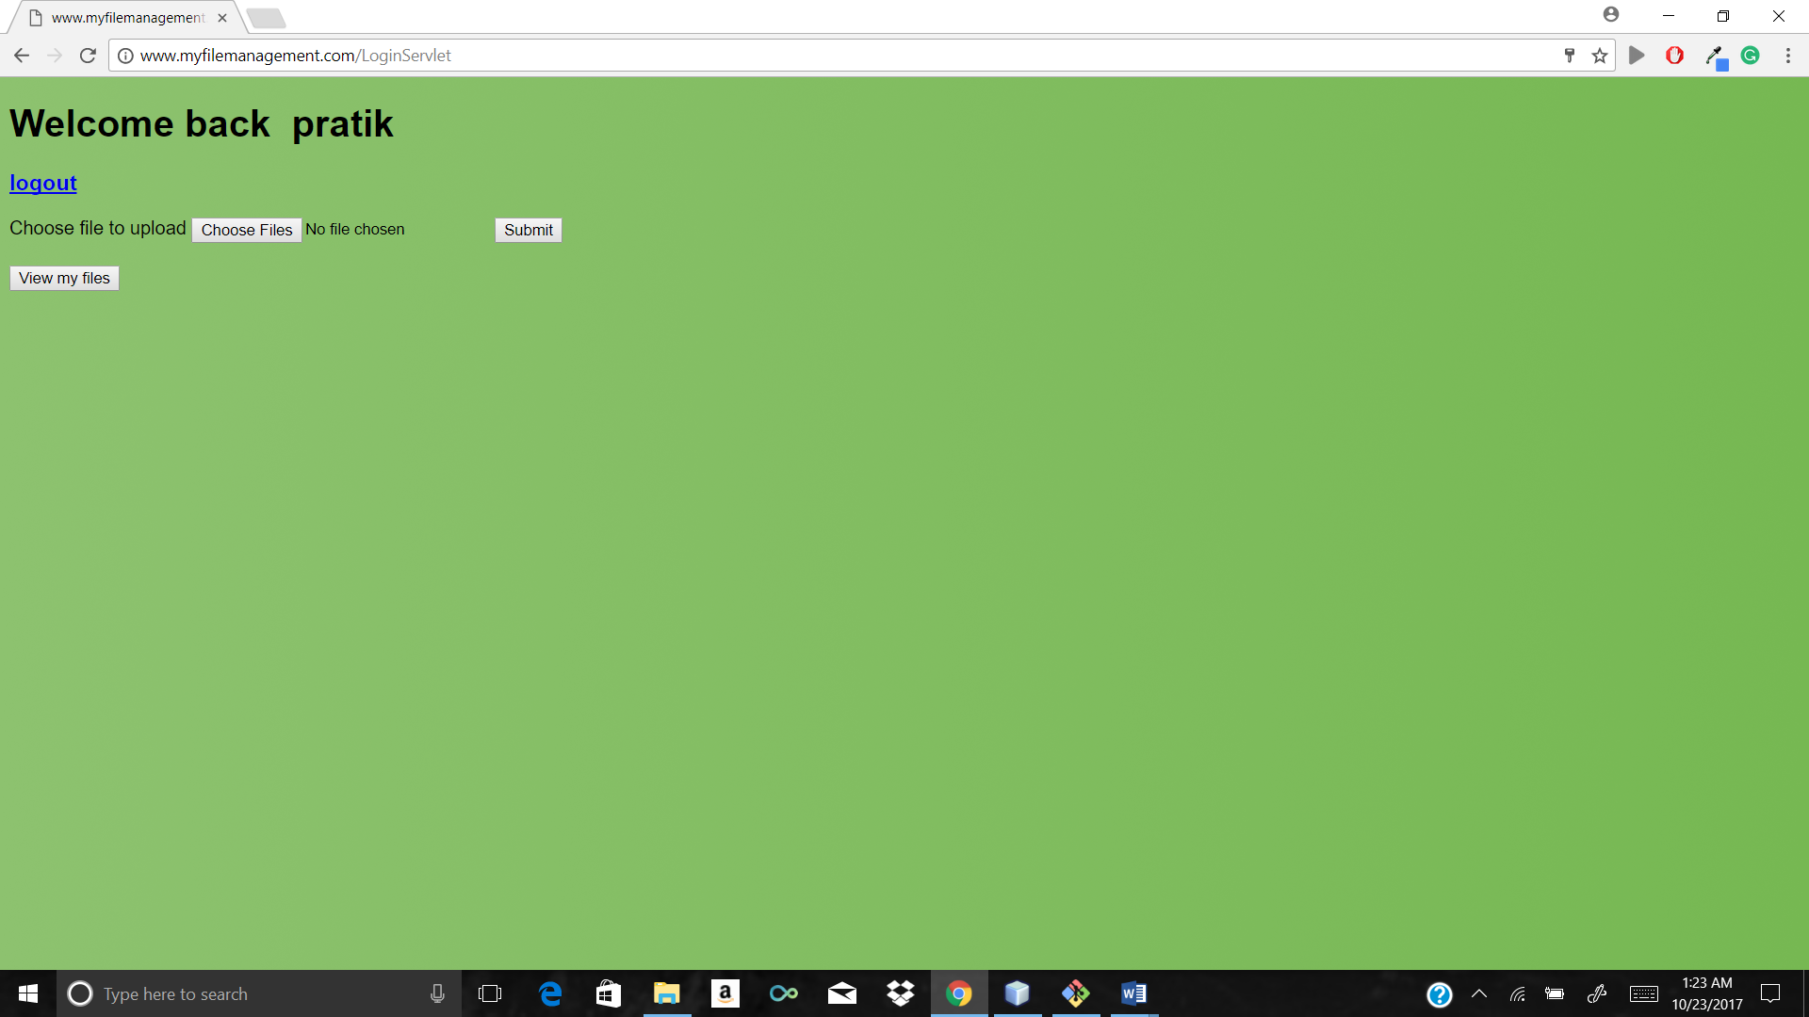

Validation message for greater than 10 MB

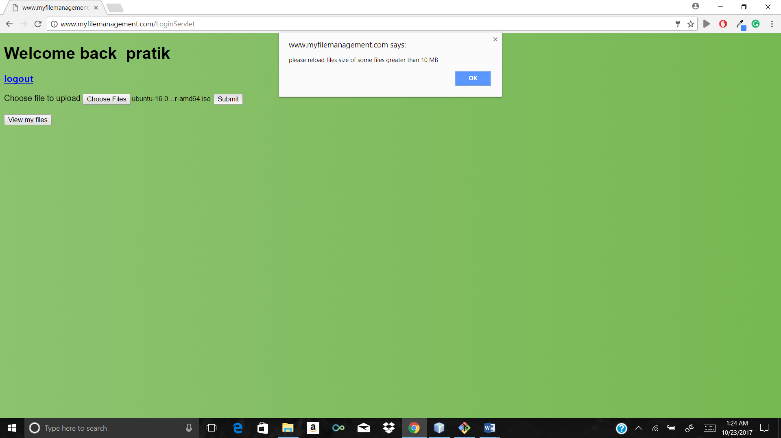

Uploading bulk of 10 files at the same time

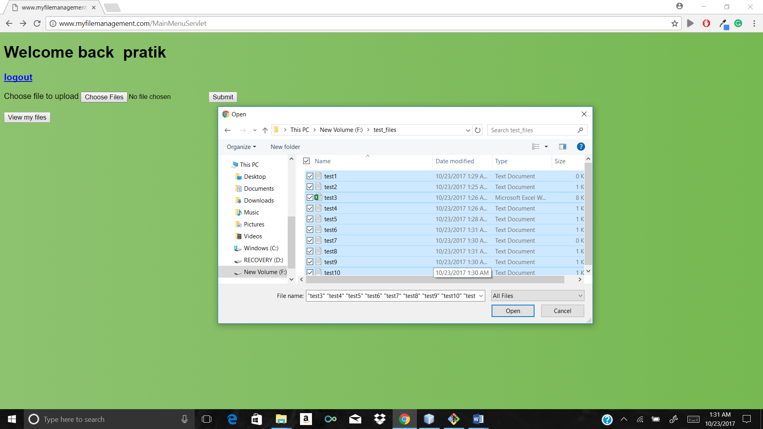

File uploaded successfully message after upload

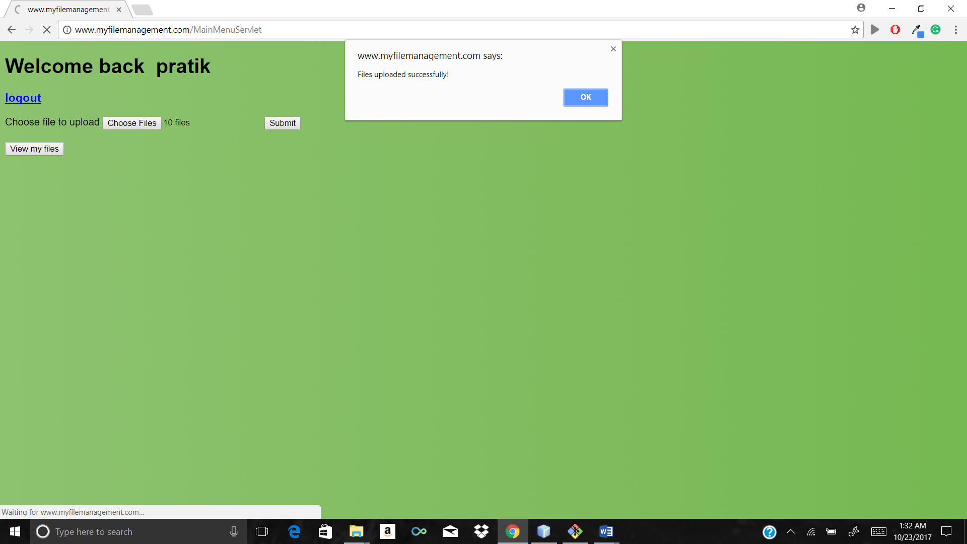

Press view my files which will show current as well as new files

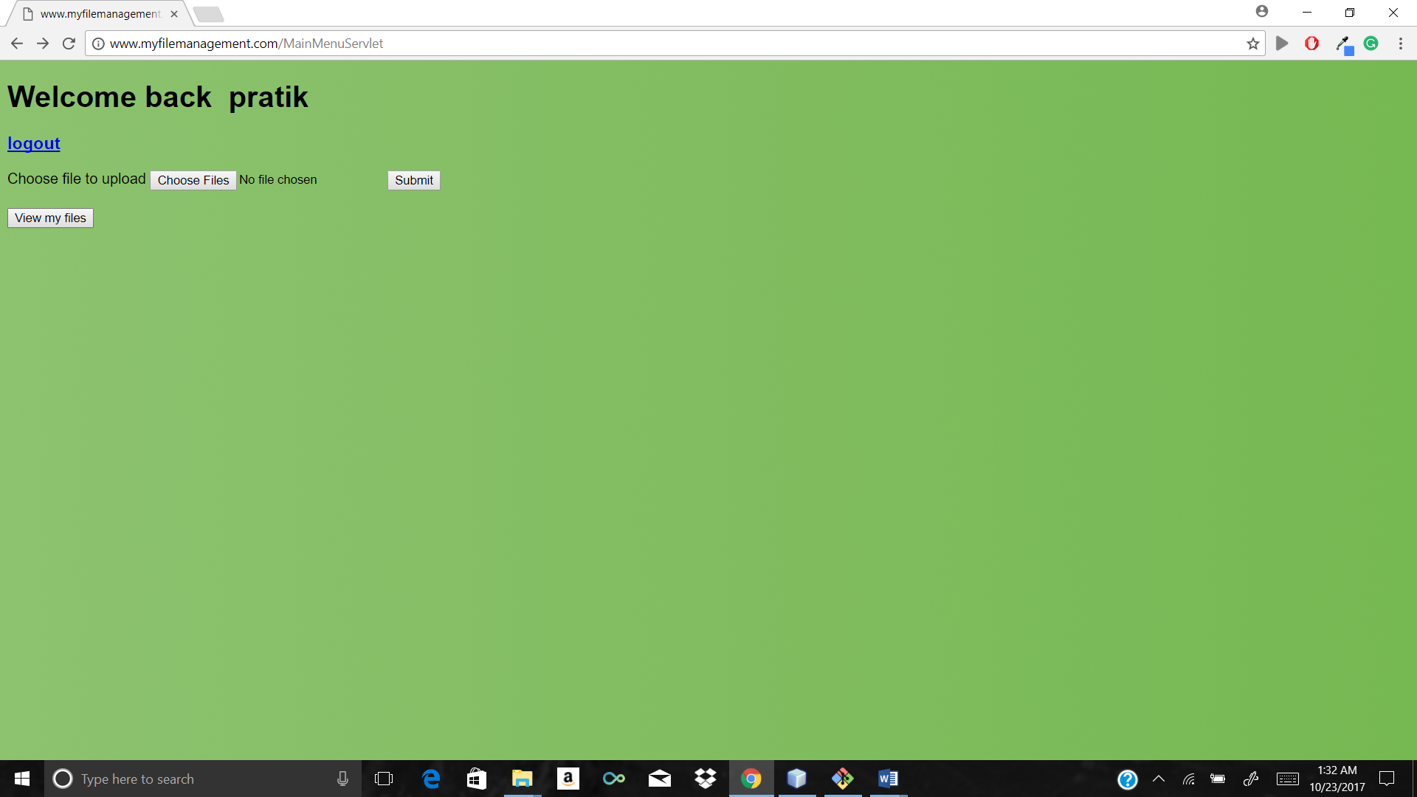

View of all the files with update, download, delete option with all the required information

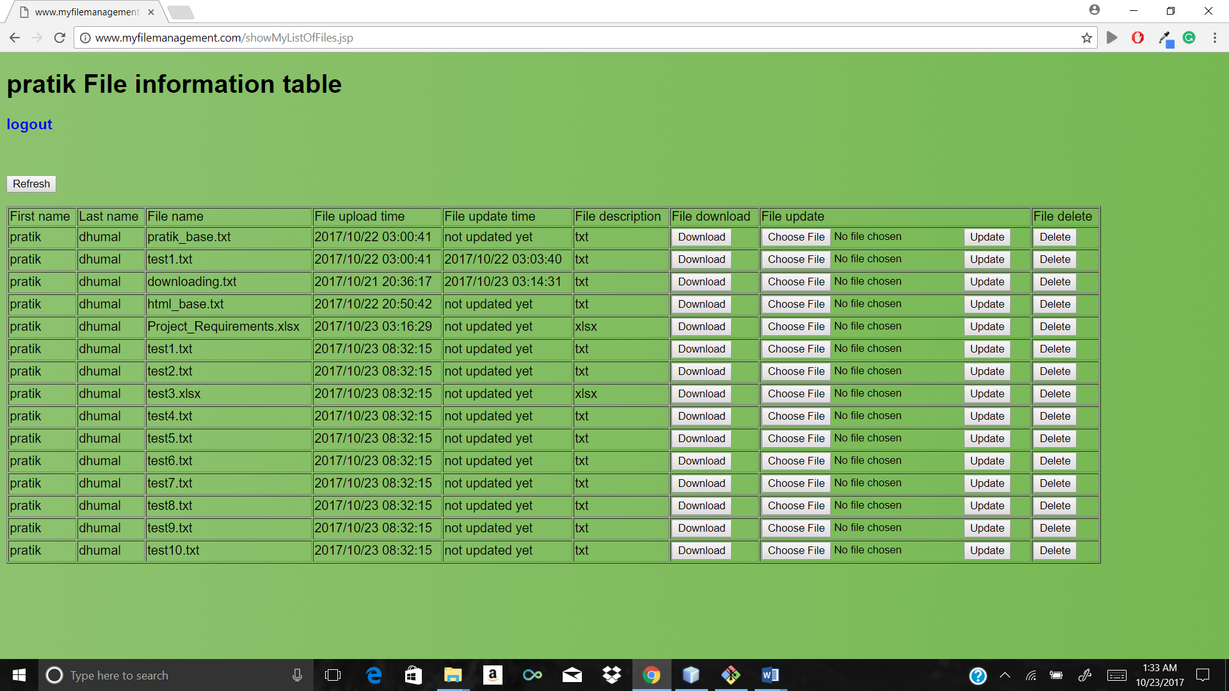

Files uploaded in actual S3 bucket Mumbai

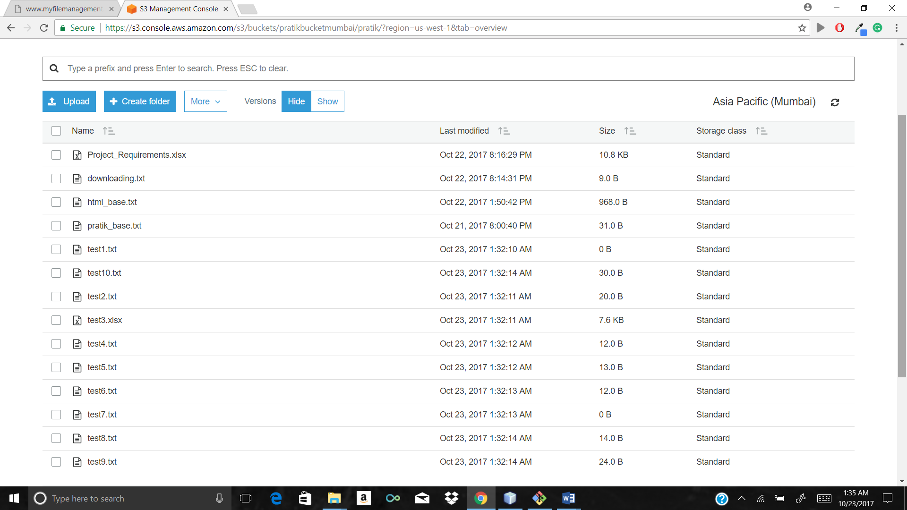

MYSQL workbench which is connected to remote MYSQL-RDS database entries 1 to many file relationship between user and file table ( user has many files foreign key to avoid redundancy)

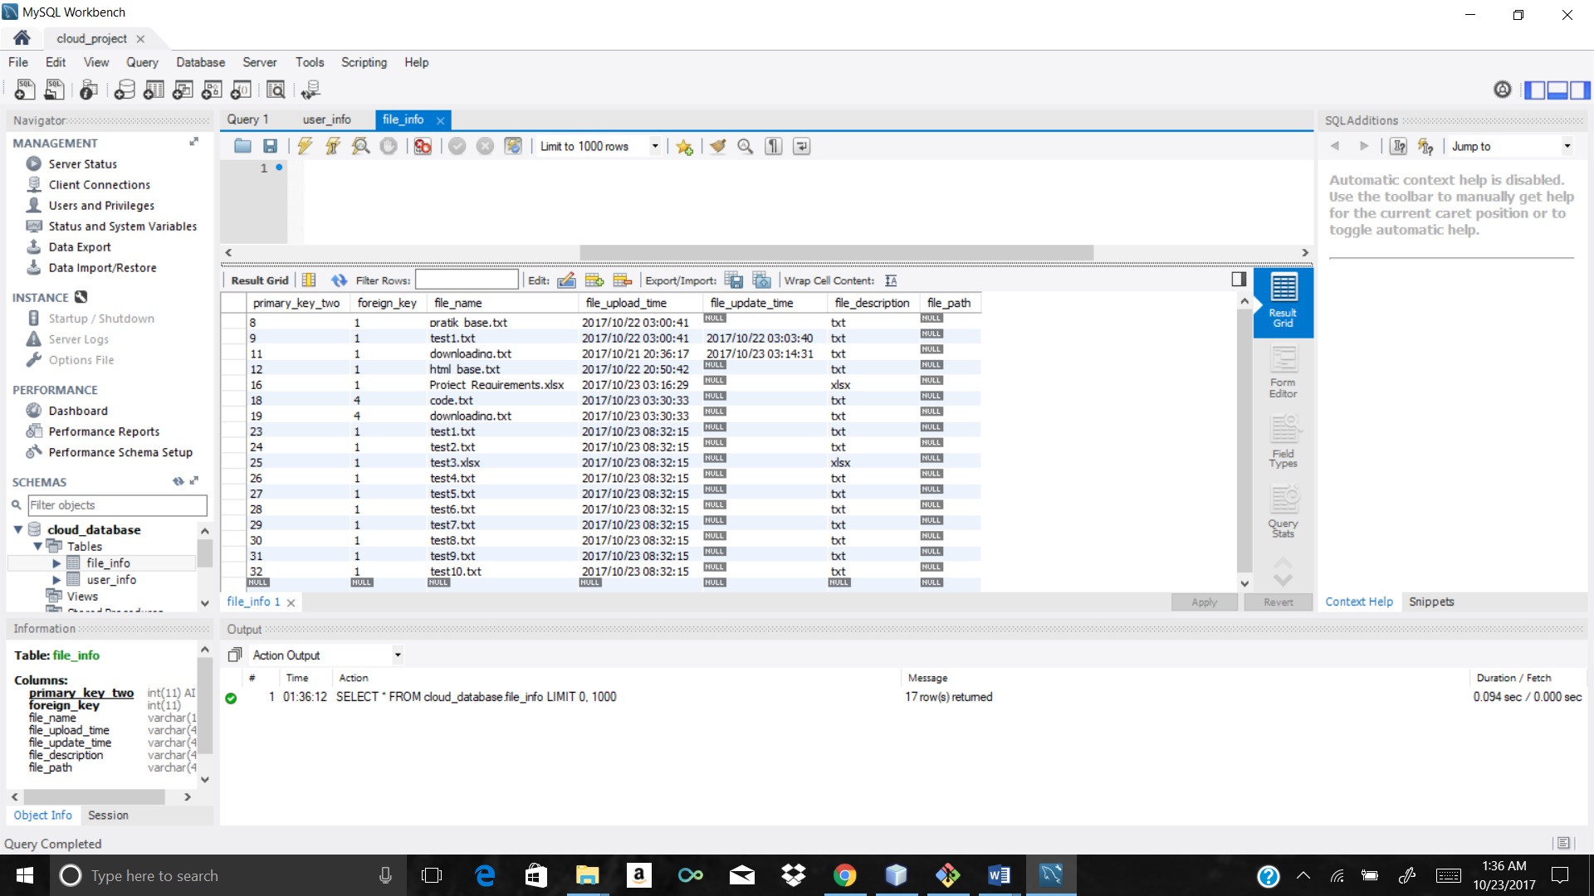

Cross region replication in bucket of London

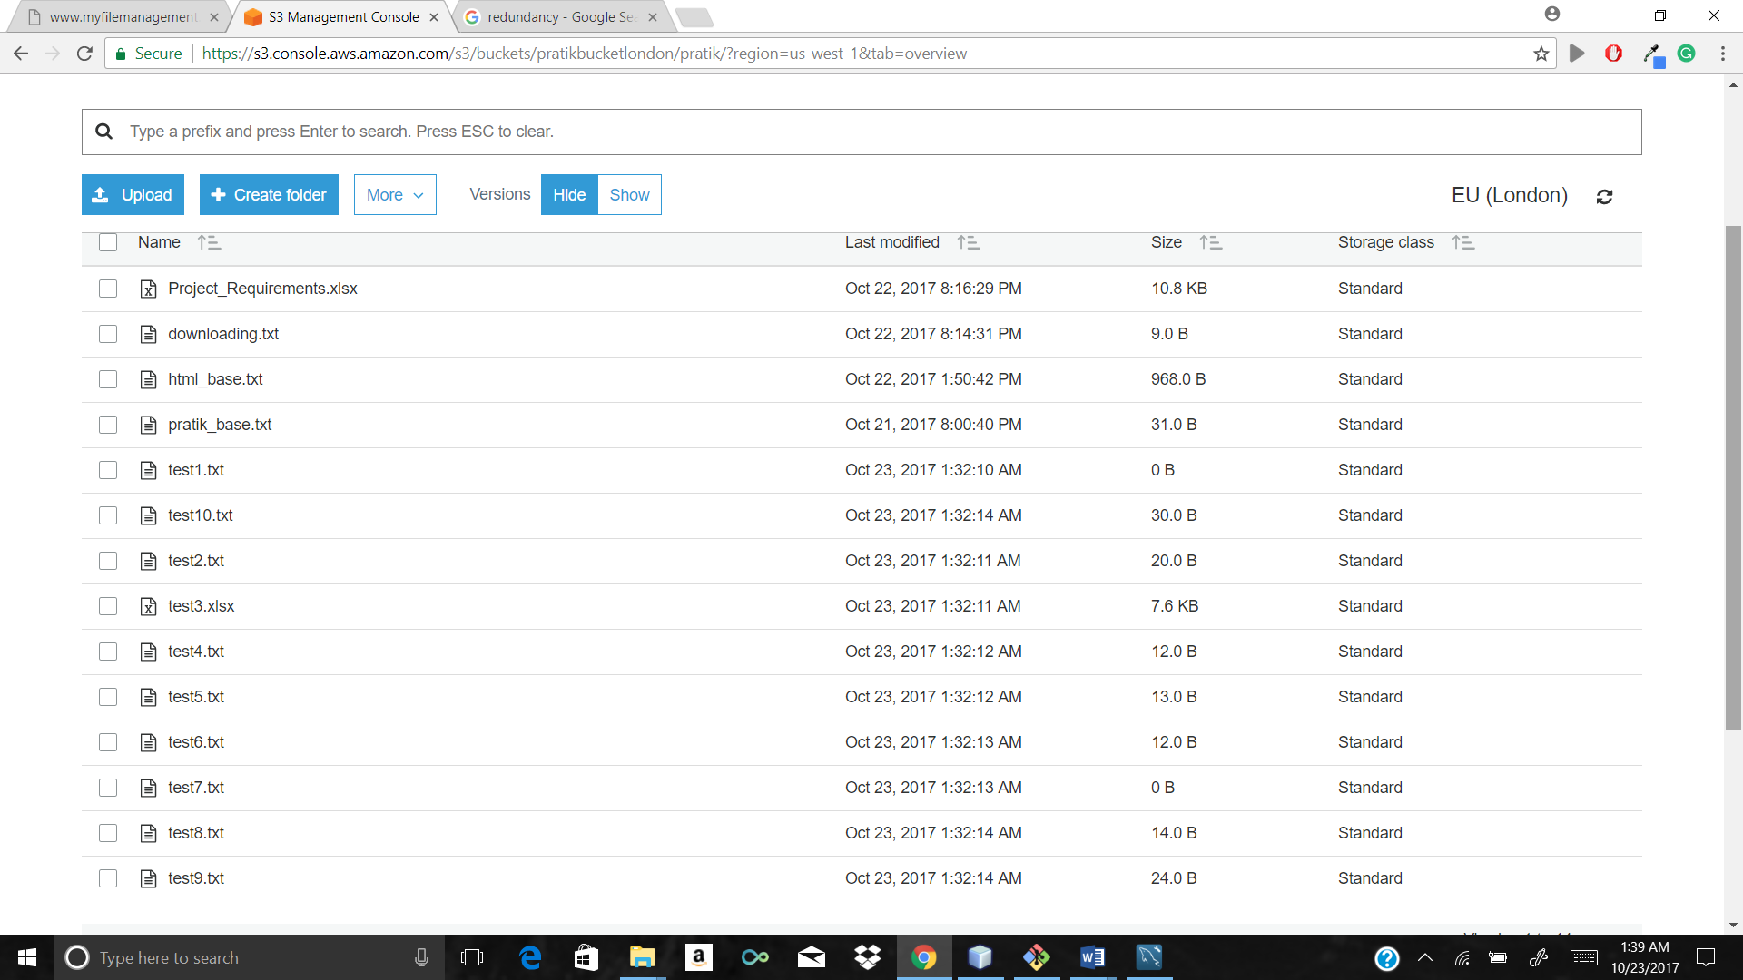

After file deletion step1 message

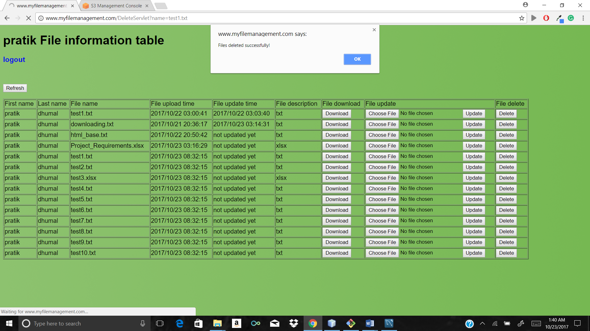

After file deletion step2 actual GUI compare both GUI auto adjusting dynamic table in jsp

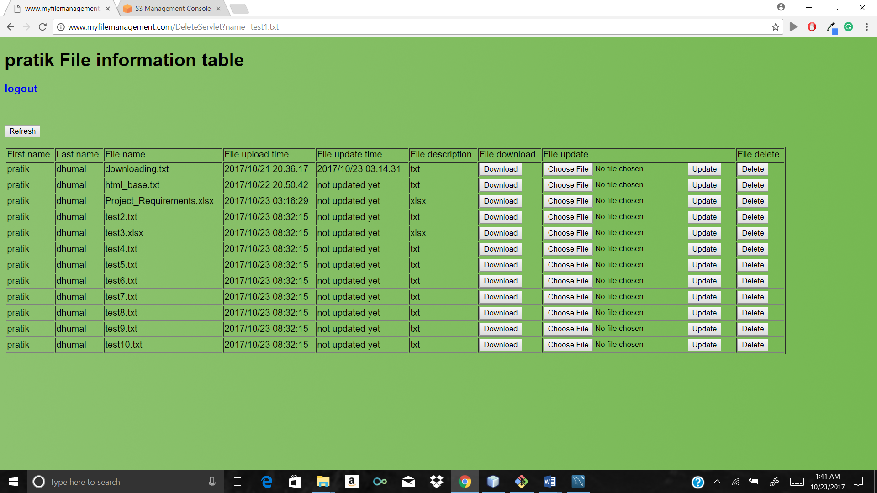

After file download and open to check content

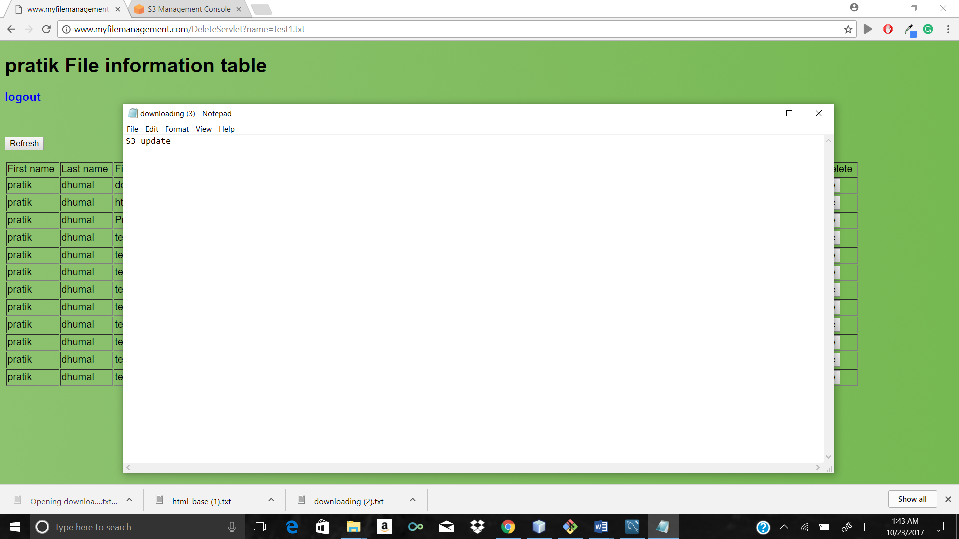

Original test 2 file after before update



After inserting some garbage data to same file

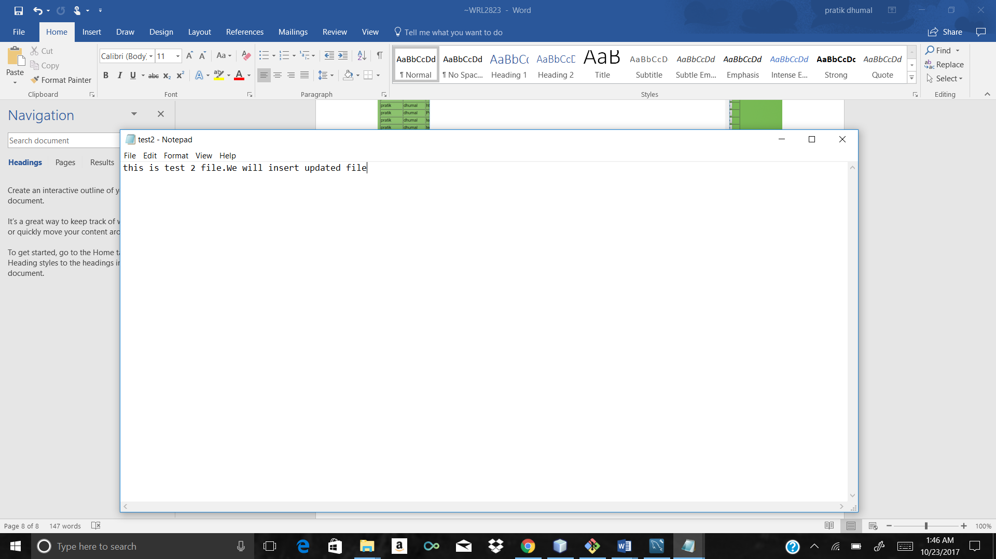

We will update the test2 file through update button

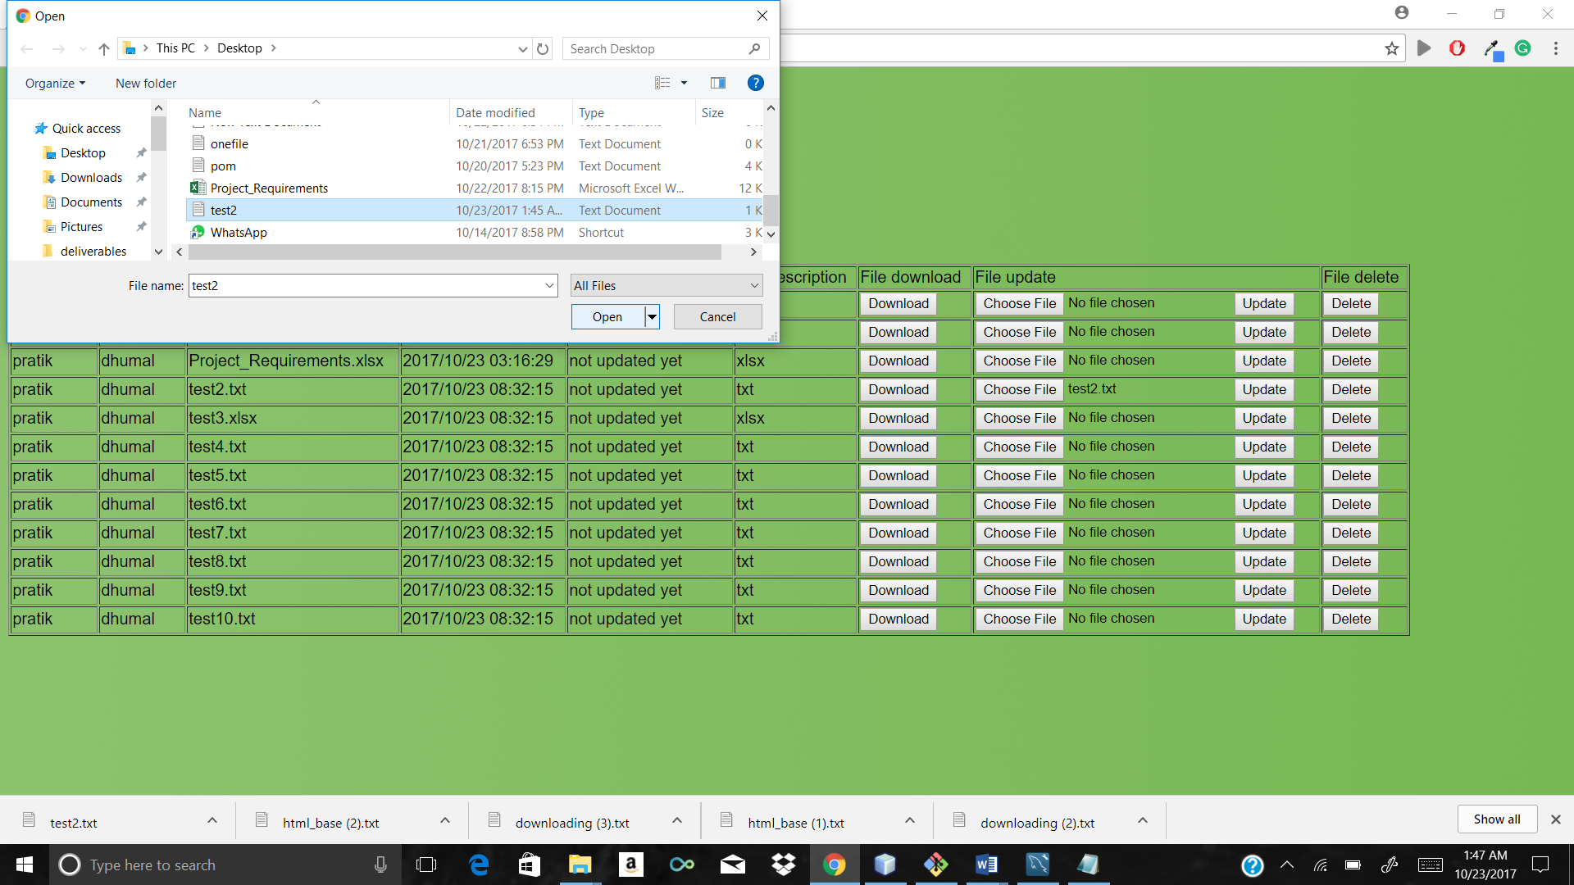

Test2 file at the button

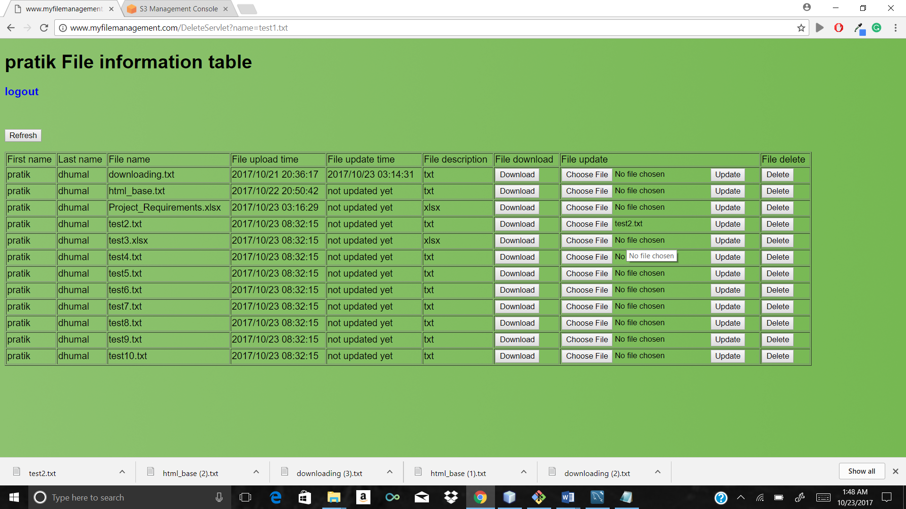

Updated file after update message and check updated time and date which is highlighted

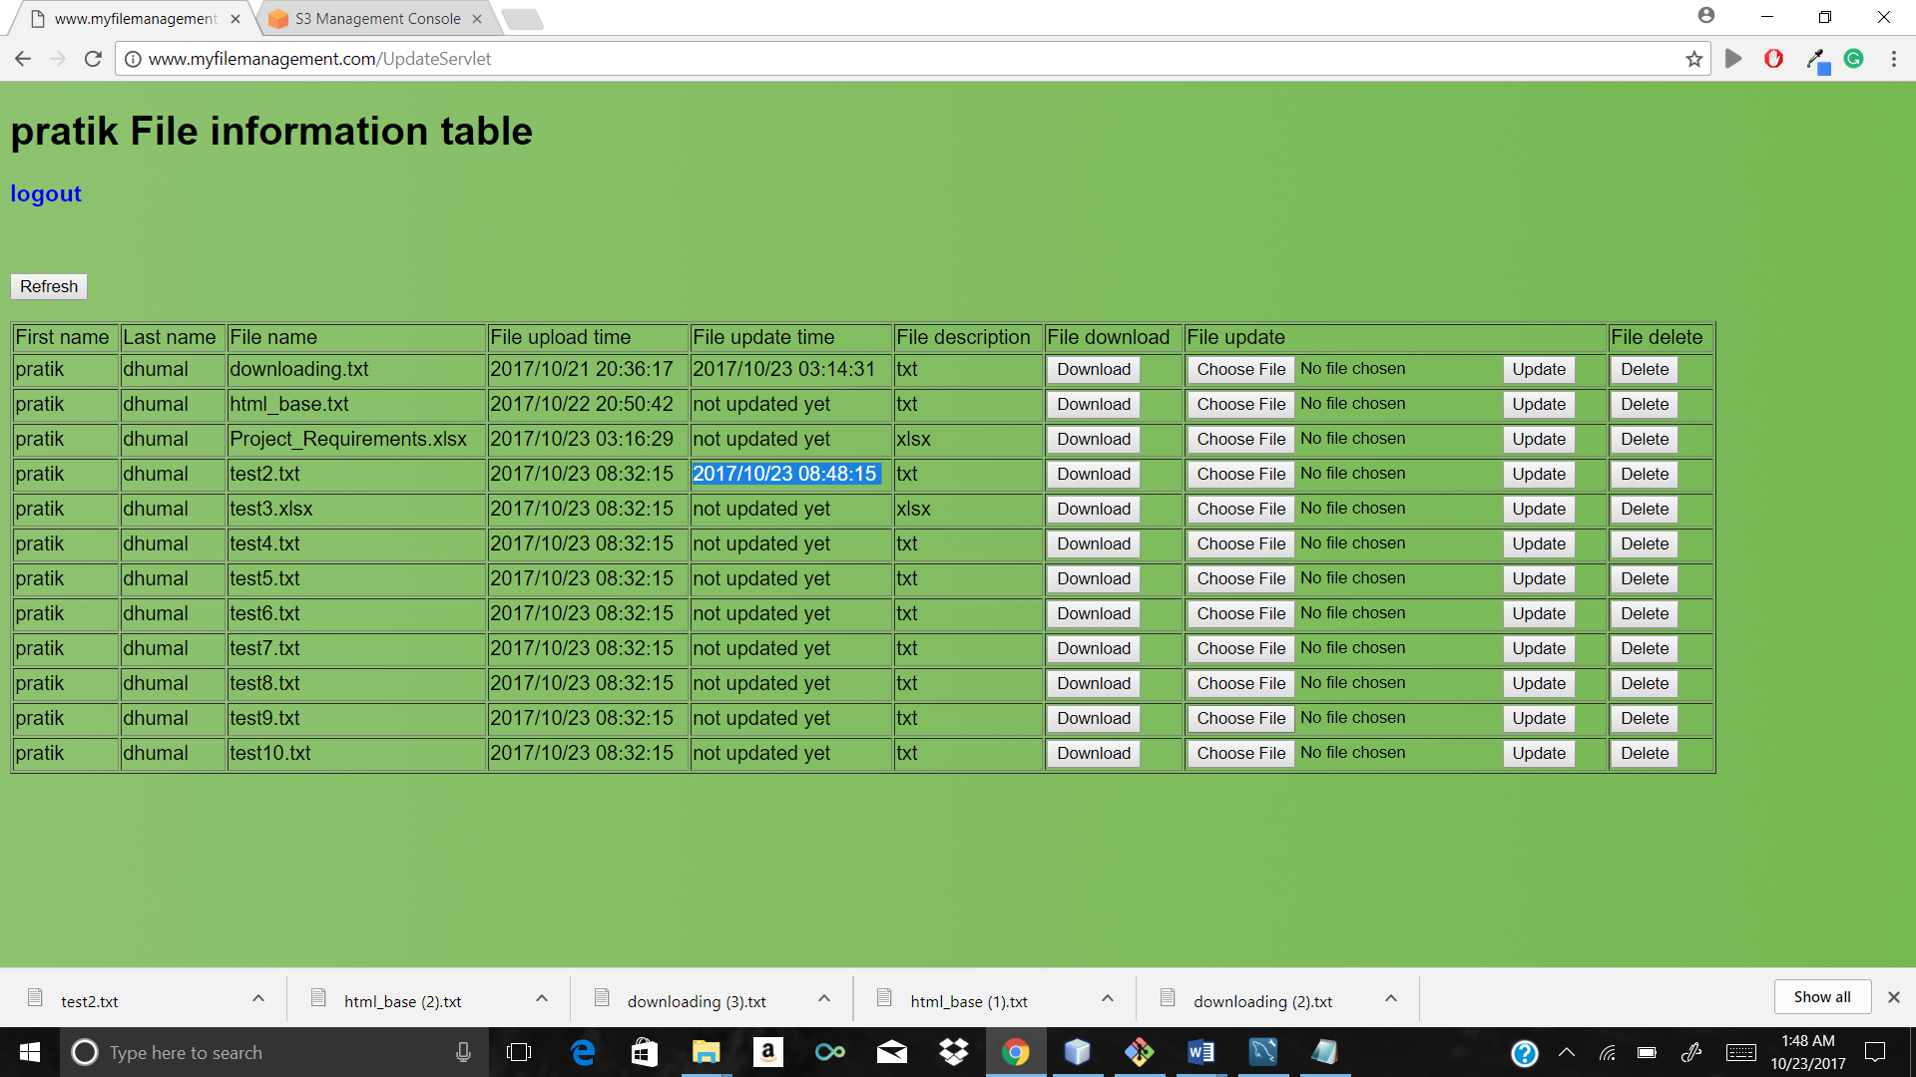

Check that file in bucket which is updated successfully

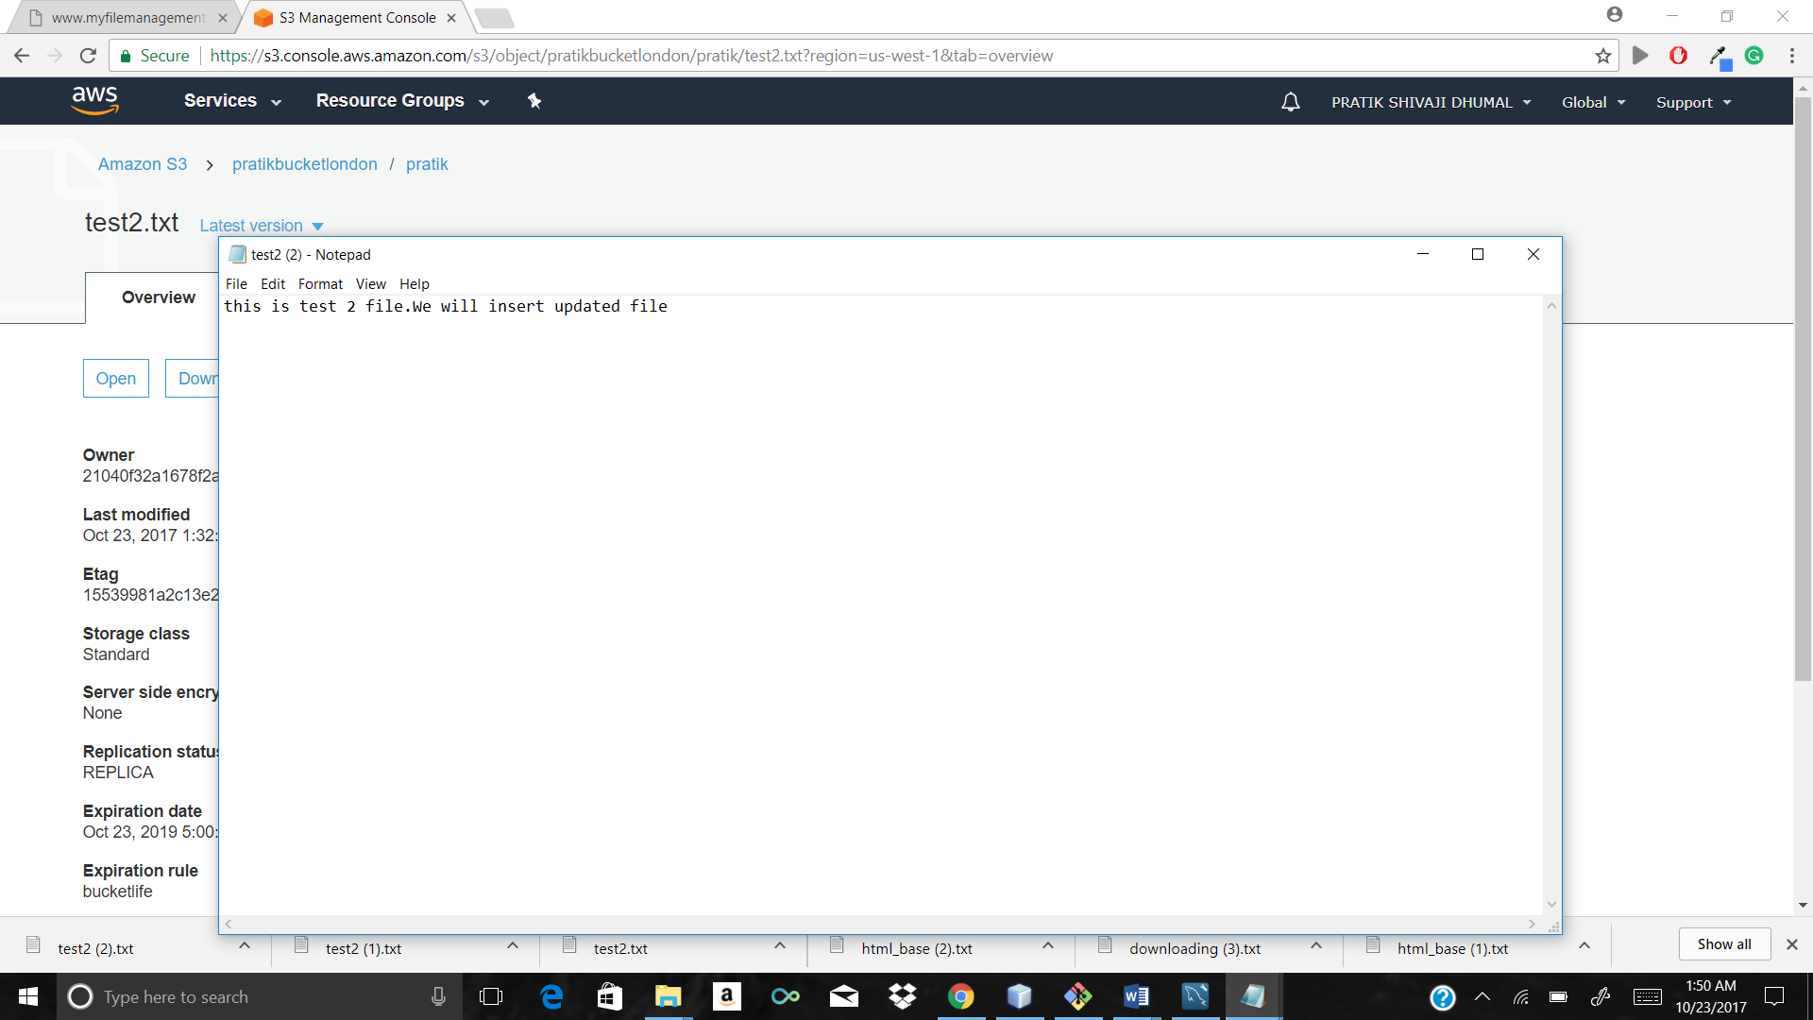

Downloading updated file from gui

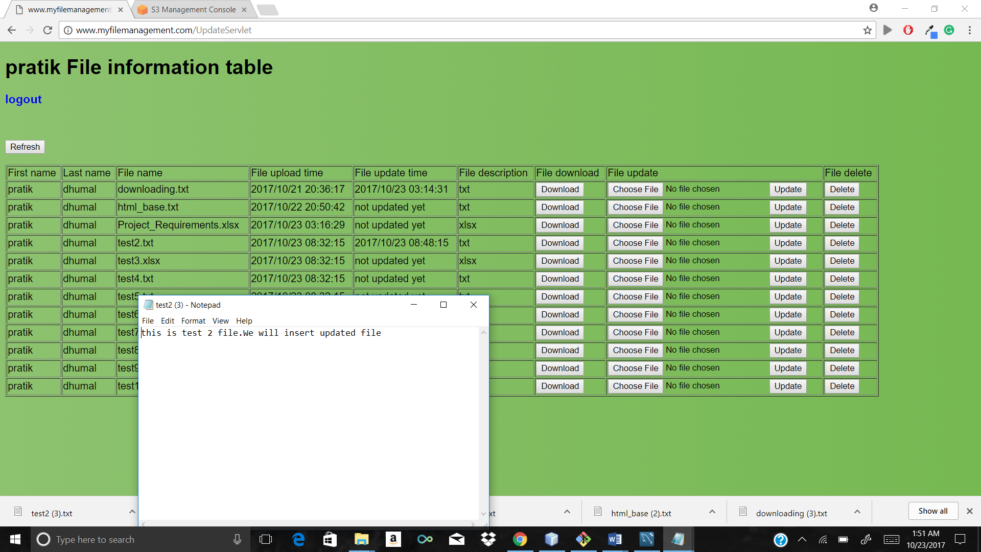

Check that file database file update time is stored there

